**Workshop agenda for Web Mapping with CartoDB**

# Links:

Shared Google Drive folder: [go.ncsu.edu/cartodb](http://go.ncsu.edu/cartodb)

[cartodb.com](http://cartodb.com)

# Instructions:

Go to [go.ncsu.edu/cartodb](http://go.ncsu.edu/cartodb)

Download **ALL-Datasets-Cartodb** folder onto your computer

Drag **ALL-Datasets-Cartodb folder to your desktop**

Create an account at CartoDB.com -- Easy way to do it is to log in with Google

# Add data sets and create maps!

After you create an account, you will get a welcome screen.

Drag & drop the **burglaries** data set from your computer into the window

When the map pops up, rename it **Raleigh burglaries**

Click the back arrow to your gallery view

In the navigation bar at the top, click Maps dropdown, and select **YOUR DATASETS**

Select **NEW DATASET** button

Drag and drop **home_prices** dataset into the window



Select **CONNECT DATASET**

Select **DATA VIEW**

Select the arrow next to the **zip** column header

Select **Georeference**

Select **Postal Codes**

Select **zip** from first dropdown menu

From Second dropdown, select free text input. Type **United States**

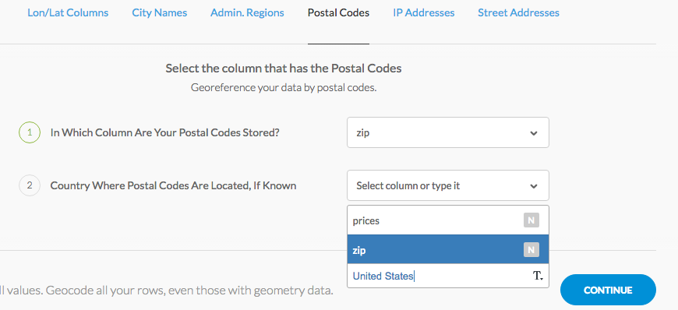

Select **CONTINUE**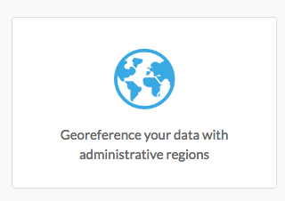

Select Georeference your data with administrative regions

After the georeferencing has finished, check it -- is it correct?

Zoom in to find Raleigh on the map

# Edit your map

Change basemap to desired look → Select **Change basemap** button at bottom of map

Change other aspects of the map with the wizard on the right panel with the paintbrush icon.

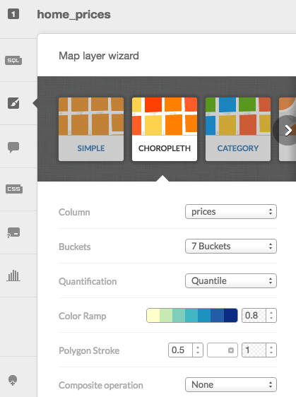

Select **Choropleth**

Make sure **prices** is selected in the Column dropdown

Change color ramp to blue tones

# Add a layer



Click on the + icon in the right menu:

Select **Create map** in order to be able to add a layer

Select the **burglaries** dataset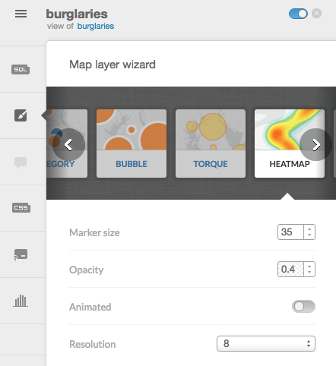

Click **Add layer**

In the map wizard, select **heatmap:**

Where are burglaries most prevalent?



Publish your map:

# Category Map

Make sure the burglaries map layer is selected

In the map wizard, select **Category**

Select column for LCR_desc (this will give us a map of burglaries by type)

**IF there is a “Null” category that shows up in your legend (otherwise ignore)**:

this is because you have null values in your data set. Ideally, this would be cleaned out before importing into CartoDB, but we can clean that up with a filter. Screen Shot 2016-02-25 at 4.22.47 PM.png

Select the Filter button from right-hand menu:

Uncheck the Null value box

The map should automatically update.

# Adding Infowindows

CartoDB gives you two choices for infowindows appearing that show details of your data: on click (when a user clicks on a data point on the map), and on hover (when a user hovers over a data point with a mouse).

Select the Infowindow icon on the right-hand menu to edit options:

Screen Shot 2016-02-25 at 4.29.53 PM.png

Use the sliders to choose which data to include in the infowindows.

Change title labels by clicking on this icon and manually editing titles:

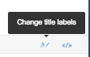

# Import a shapefile

Select DATASETS from the dropdown menu

Drag and drop **nc_cnty.zip** into the window

Select **MAP VIEW** to see the map.

This is a map of NC County boundaries

Add a new dataset: **nc_pov_by_county.csv**

This doesn’t georeference well. That’s ok!

# Create a Join

Go to the map view for **nc_counties**

**Edit >**

**Merge with dataset…**

**Column join**

Under nc_counties, select **name**

On the right side, choose **nc_pov_by_county**

Select **countyname**

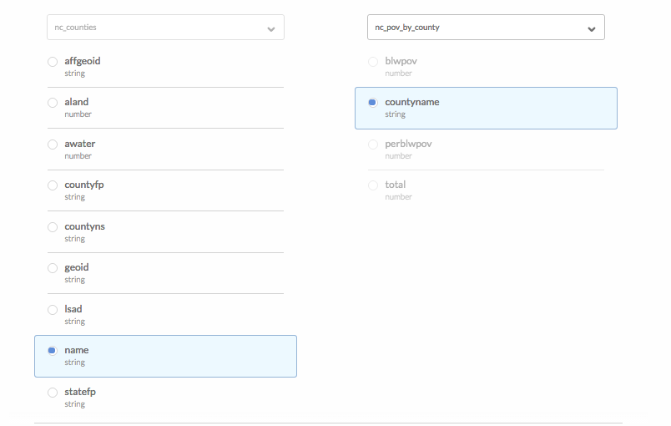

Select **NEXT STEP**

Choose desired fields to join

Select **MERGE DATASETS**

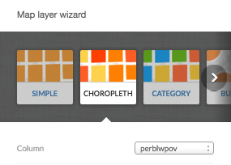

Using the Wizard, change to **Choropleth** map

Make sure the column is set to **perblwpov**

Which counties have the highest percentages of their populations living below the poverty level?

# Create a Map with Multiple Layers, Including Streets

We will be working with data from Raleigh that I downloaded from WakeGov’s GIS Services site: <http://www.wakegov.com/gis/services/Pages/data.aspx>

You can access these datasets in the [go.ncsu.edu/cartodb](http://www.go.ncsu.edu/cartodb) folder.

Add the **Wake_MajorRoads_2016_03.zip** dataset to CartoDB

Click Connect Dataset

Click on the + sign on the right hand side

Click **OK, Create Map** button

Click Connect Dataset

Drag and drop **Wake_MajorStreams_2011_10.zip** into the window

Click Add Layer button

Click on the + sign on the right hand side

Click Connect Dataset

Drag and drop **Wake_PublicOpenSpace_2016_03.zip** into the window

Click Add Layer button

Now click on Map View. The map should have 3 layers. Look for a 3 in the right-hand menu at the top. Now you can edit each layer individually.

You can use the wizard to change the colors of the elements so it’s easier to distinguish between roads, rivers and public open spaces.

# Making a Tweet Map (upgrade required - no longer free :( )

The CartoDB free account allows you to import up to 10,000 tweets for free and visualize those on a map. You get all of the rich data that Twitter attaches to tweets, including user location, profile picture, the tweet text, time posted, number of re-tweets, etc. You can create a search using up to 4 terms and the data is automatically imported into CartoDB as a dataset.

To load in Twitter data, go to Datasets.

Click on the Twitter button.

Select how many credits you would like the search to use and the data range for the tweet harvest.

Once you have created the dataset, click on Map View

From here, you can edit your infowindow to include images of Twitter users, along with other information. 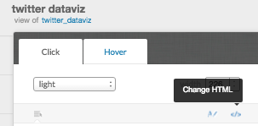

Select the Hover tab.

Click the light blue </> button to change the html (it’s hard to find)

Add the line in bold below to get an image to show up in the infowindow:

<div class="cartodb-tooltip-content-wrapper">

<div class="cartodb-tooltip-content">

<h4>actor_displayname</h4>

<p>{{actor_displayname}}</p>

**<p><img src={{actor_image}}></p>**

<h4>body</h4>

<p>{{body}}</p>

<h4>actor_preferredusername</h4>

<p>{{actor_preferredusername}}</p>

</div>

</div>

# Data sources:

* Home prices are from Zillow: <http://www.zillow.com/raleigh-nc/home-values/>
* Burglary data is from Open Data Raleigh - <http://bit.ly/1R98pdz>
* NC Counties shapefile - <http://www.ers.usda.gov/data-products/county-level-data-sets/poverty.aspx>
* Poverty data is from Social Explorer - <http://www.socialexplorer.com>
* Wake County Data is from WakeGov GIS Services: <http://www.wakegov.com/gis/services/Pages/data.aspx>
* Twitter: Twitter API, which is integrated into CartoDB